**Market Research Report: Dmart vs. Smart Bazaar**

Conducted as part of MBA Research at JECRC University

**Author: Goverdhan Dadhich**

**1.Introduction**

As part of my MBA research at JECRC University, I conducted an in-depth study of two major retail giants—Dmart and Smart Bazaar. This research involved a comparative analysis of their product offerings, operational strategies, and overall business models. My objective was to gain insights into the retail industry and understand how these two brands function in a competitive market.

**2.Research Methodology**

To ensure a comprehensive study, the following approach was undertaken:

* **Product Comparison**: Analyzed the product range, pricing, and quality offered by both retailers.
* **Managerial Insights**: Conducted interviews with managers at Dmart and Smart Bazaar to understand their strategies and operational challenges.
* **Strategy Analysis**: Evaluated their business models, customer engagement techniques, and supply chain management.

**3.Meeting with Store Managers**

During my research, I had the opportunity to meet with the managers of both Dmart and Smart Bazaar. These discussions provided firsthand insights into their operational strategies, challenges, and unique approaches to customer satisfaction. Key takeaways from these meetings included:

* **Dmart Manager**: Emphasized cost control through direct vendor relationships and bulk purchasing strategies.
* **Smart Bazaar Manager**: Highlighted the importance of branding, promotional campaigns, and customer engagement strategies.

These conversations helped bridge the gap between theoretical knowledge and real-world retail management practices.

**4.Key Findings**

**Product Offerings and Pricing**

* **Dmart**: Offers competitive pricing with a strong emphasis on bulk purchasing and private labels to reduce costs. Focuses on essentials and household items.
* **Smart Bazaar**: Provides a wider variety of branded products, often targeting an urban audience with a more premium shopping experience.

**Customer-Centric Approaches**

* **Dmart**: Attracts value-conscious customers through everyday low prices and efficient in-store operations.
* **Smart Bazaar**: Uses promotional campaigns and discounts to engage customers and enhance brand loyalty.

**Supply Chain and Operational Strategies**

* **Dmart**: Highly efficient supply chain with direct vendor relationships and limited middlemen, ensuring cost control.
* **Smart Bazaar**: Leverages a broader distribution network, ensuring a vast range of products but with higher operational costs.

**Store Layout and Shopping Experience**

* **Dmart**: Simple, no-frills store design focusing on quick and easy purchases.
* **Smart Bazaar**: More organized sections with a focus on branding and aesthetics to enhance the shopping experience.

**Promotional and Discount Strategies**

* **Dmart**: Focuses on everyday low pricing, relying on cost-cutting strategies to maintain affordability.
* **Smart Bazaar**: Frequently runs promotional offers and seasonal discounts to attract customers and boost sales.

**Customer Footfall and Sales Trends**

* **Dmart**: Steady customer flow due to its reputation for affordable prices and essential goods.
* **Smart Bazaar**: Experiences higher footfall during promotional events but fluctuates during non-sale periods.

**Digital and Online Presence**

* **Dmart**: Limited online presence, with a stronger focus on physical retail stores.
* **Smart Bazaar**: Actively expanding its e-commerce operations to cater to online shoppers and increase digital engagement.

**5.Store Visit & Images**

As part of this research, I visited both Dmart and Smart Bazaar to observe their store layouts, product arrangements, and customer interactions. Below is an image captured during my visit to Smart Bazaar, Jaipur:

This visit provided a real-world perspective on how these retailers operate and engage with customers.

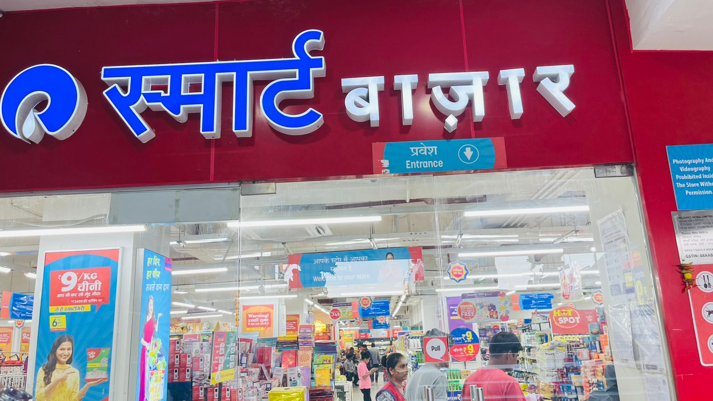

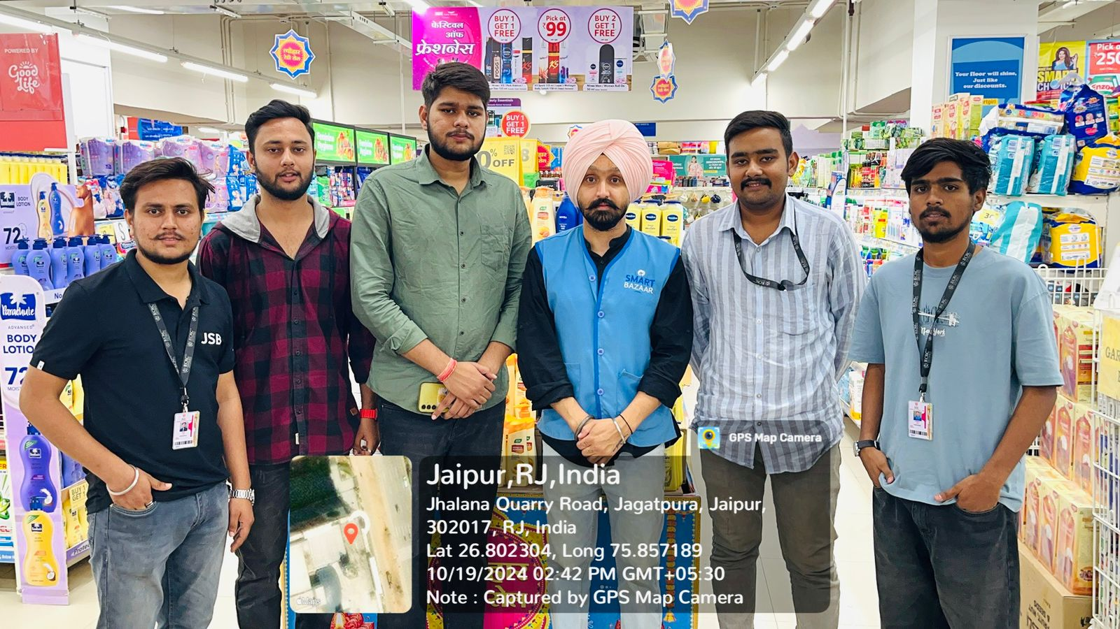

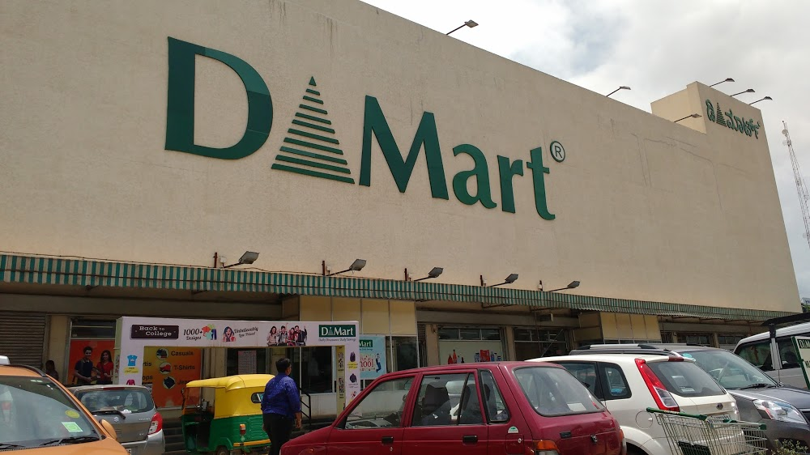

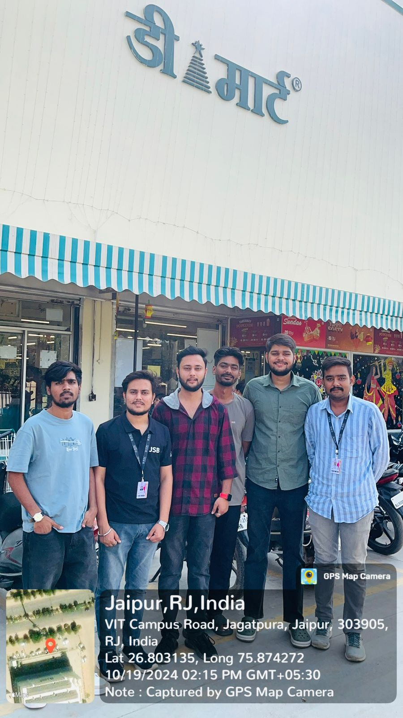

**Photo Documentation**

To further illustrate my findings, here are additional images from my store visits:

* Dmart Store Layout & Product Display

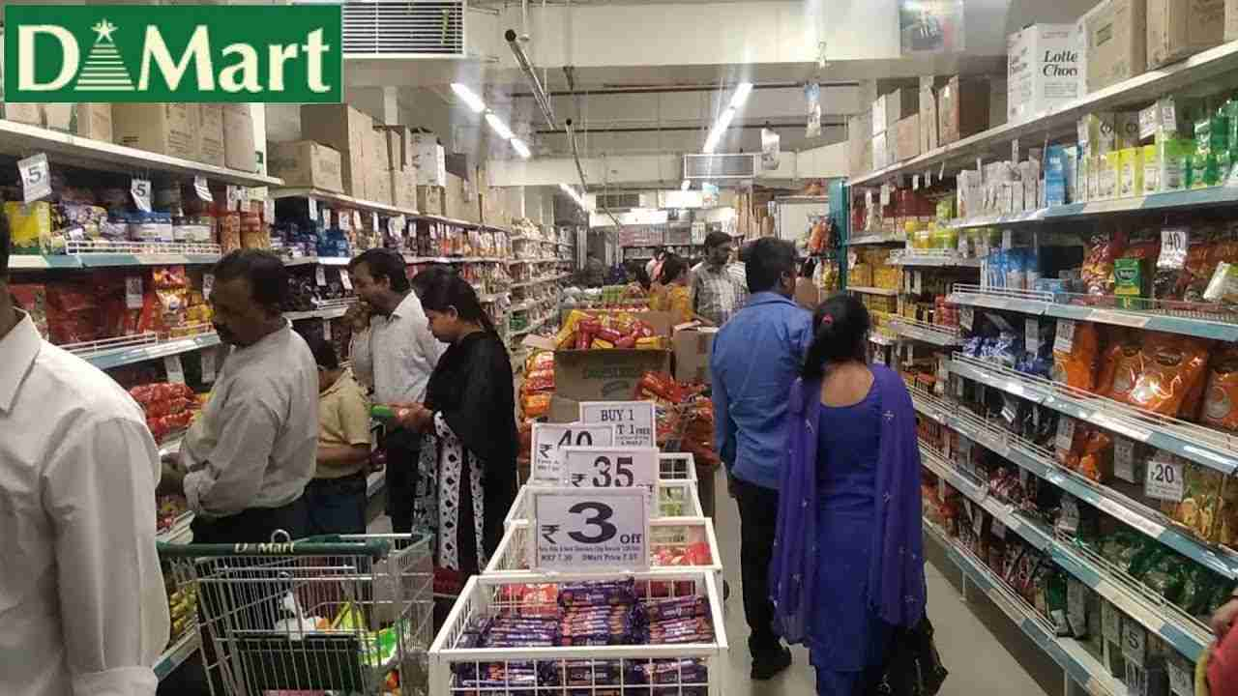

* Smart Bazaar Checkout Counters & Billing Experience



These images provide a visual representation of the shopping experience and store environments at both retailers.

**Conclusion**

This research provided valuable insights into how Dmart and Smart Bazaar operate within the retail space. Dmart’s cost-efficiency model contrasts with Smart Bazaar’s branding and promotional strategies, each catering to different customer segments. Understanding these differences has enhanced my knowledge of the retail industry, supply chain dynamics, and consumer behavior.

A special thanks to the managers at both Dmart and Smart Bazaar for their valuable time and insights. This study will serve as a stepping stone in my academic and professional journey in the field of business and retail management.